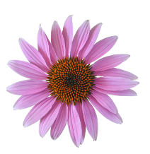
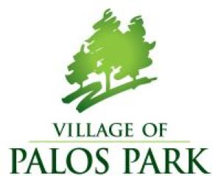
2024 Purple Coneflower Order Form
Complete this form to purchase Purple Coneflower seedlings, also known as “plugs.” Each plug costs $2.00, will have fully developed 5” root systems, are ready to install, and quickly develop into mature plants. The plugs are neonicotinoid-free (neonicotinoid pesticides are a class of insecticides that can harm bees, butterflies, and other pollinators).
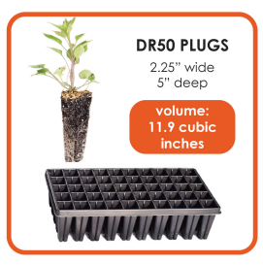
____________________________________
Name

____________________________________
Phone

____________________________________
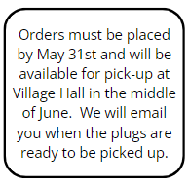
Email Address

___ 3 Plugs ($6.00) Total $____________

___ 5 Plugs ($10.00) Total $____________

___ 10 Plugs ($20.00) Total $____________

Total Plugs ______ X $2.00 = Total Amount Due $____________
Payment Options:
Cash and checks are accepted at Village Hall; make checks payable to: Village of Palos Park.

